CNC Bending Machine Control System
Instruction Manual

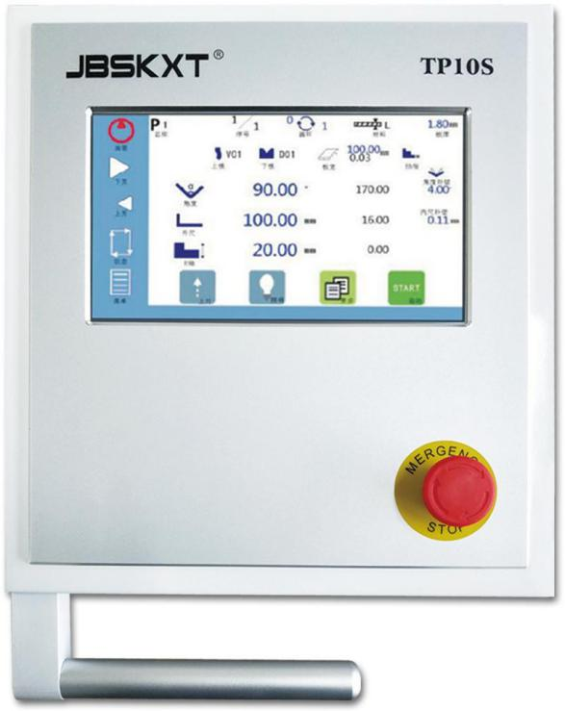

Introduction

Content description

A manual on the TP10S bending machine control system product installation, technical specifications and application examples. The sections are summarized as follows:;
- Chapter 1(operation panel) introduces the use of operation panel of bending machine control system;

- Chapter 2(Application Example) illustrates how to operate the control system;

- The appendix provides the interface specification, FAQ processing and so on for users to browse quickly.

Applicable object

this manual provides information on the installation and commissioning of TP10S bending machine control system products designed for engineers, maintainers and electricians with general knowledge of automation.

Introduction 2
1 Operational panel 4
  - Basic Page Introduction 4
    - Programming page 4
    - More data settings 4
  - Parameter Settings 7
  - Machine state 12
  - Manual movement 14
  - Mold management 15
    - Top Editor 15
    - Lower Mode Editor 16
2 Examples of applications 18
  - Example Description 18
  - Operation steps 19
Appendix 2 2
A Analysis and treatment of common problems 22

Basic Page Introduction

Programming page

The following is the home page of the bending machine control system
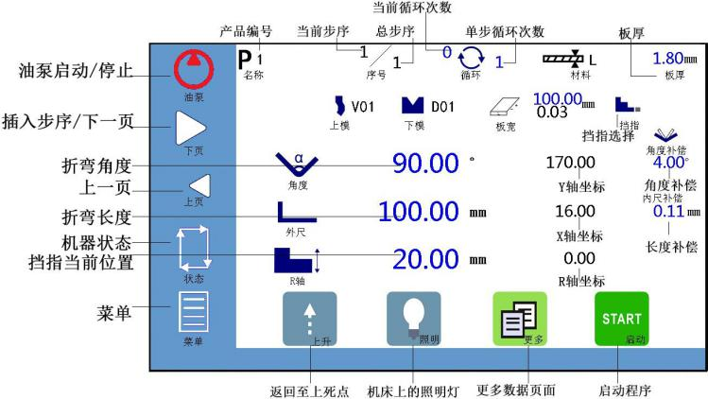

More data settings

Click on the icon on the main programming page to enter more data settings pages:
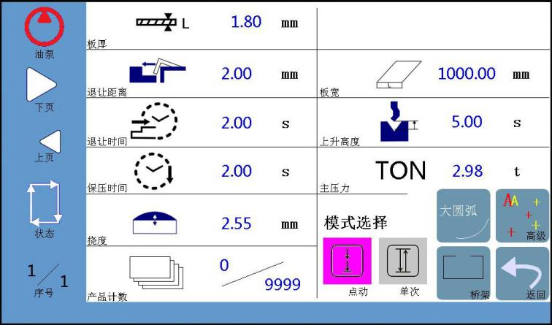

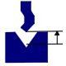

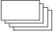
Table 1-1 Parameters (I)

Parameters | Definition | Remarks
Plate thickness | Thickness of individual workpieces
Back Blocking | Concession distance of retaining material (X shaft) per step  (i) | Enter the concession distance in the rear domain
Return distance/time | Backward distance/time (available at each step) of upper mode (Y axis), starting at the change point, | The setting is short, if the upper die has not reached the upper dead point after this time, then stop moving up and enter in single or continuous mode  Next steps
Pressure holding time | Time from the change point to the start of the machine  (per step)
Workpiece count | Number of currently processed workpieces/set total workpieces  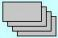Number of pieces, not available
Bending width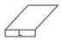 | Width of processed sheet
Bending pressure TON | Pressure applied during bending | Options
Deflection compensation | Compensate the deflection deformation of workpiece during machining | Options
Large arc | Enable Large Arc
Bridge | Capability of bridge

Click to display more data settings, different working modes corresponding to the page is different, the following is the point mode corresponding interface:

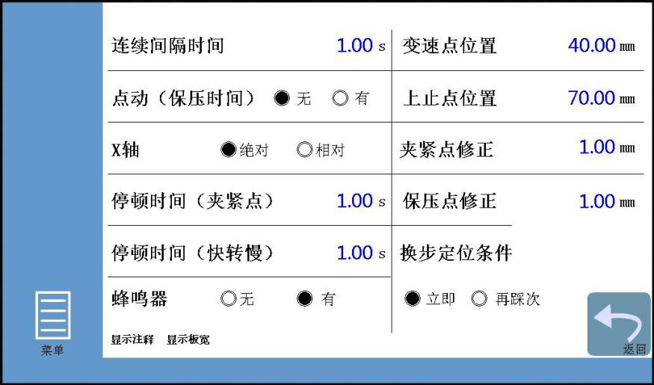

Table 1-2 Parameters (II)
Parameters | Definition | Remarks
Point movement / no holding time | If effective, stop slow at hold time  And pressure relief, pressure relief after the completion of no automatic return | If you step down to the change point, release the foot,  Equipment also releases pressure automatically
X axis incremental / absolute | Choose X axis position motion mode
Change point position | Slider changes from fast to slow
Upper stop position | Maximum slider stroke
Clamping point correction | Compensate according to the position of the clamping point
Pause time (pinch point) | Stop time when the slider changes from slow down to clamping the workpiece | After the X axis concession position is completed (or after the pause time) continue to slow down, if the pause  The time is set to 0 and will slow down and bend
Pause time (quick turn slow) | The pause time of the slider from fast down to slow down | After this pause, slow down if  The pause time is set to 0, and the slider moves down quickly and slowly

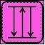

Parameter Settings

Click on the menu icon on the main page of the program, and select "parameter settings" in the pop-up menu to enter the parameter settings page.
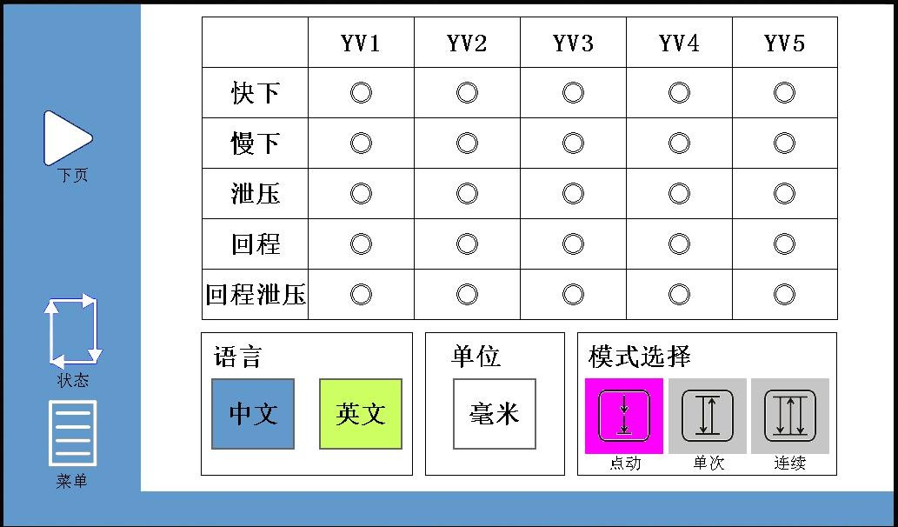
You can configure the operation parameters on this page, please refer to the following steps for parameter setting.

1. can choose YV1~YV5 valve output configuration, interface language, working mode on the main page of parameter setting.

- Sliders have four motion states: fast down, slow down, return, pressure relief

Different models of 4 motion state output may be different, so here to output configuration (YV1~YV5).

- Interface Language Selection: Chinese and EN (English) Optional

- Working mode selection: click, single, continuous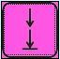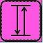

Table 1-3 Working patterns
Mode | Note
Point mode | Click (or step down once) to start the program, step down the slider and stop. Step on the slider to move up, release and stop; when released above the change point X the rear gear of the shaft  Material back to the original, easy to bend the same step again. Support system automatic step change in point mode.
Single Mode | Click (or step down once) to start the program, step down, the slider moves down and presses down to the end, automatically return after the pressure holding time arrives, and enter the next step.
Continuous mode | Click (or step down once) to start the program, step down, the slider moves down and presses down to the end, the pressure holding time arrives automatically return, enter the next step, so cycle until all steps are in place  The number of artifacts is finished. In continuous mode, you can set continuous intervals on more data settings pages

>< remarks

- Point mode is used in calibration, single mode is used in normal operation, continuous mode is used in testing machine.

- At "manual movement" and "X/Y/R axis navigation ", the mode automatically changes to slow point mode, and automatically switches to the original mode after exiting these pictures.
- If you step on the foot switch, then step on the switch is invalid; release the foot switch, then step on the switch is effective.
If the program is not started, the first step (or on the screen) will start the program, and then step down again.
In single mode or continuous mode, the slider moves upward. If the return time is effective and the return time arrives (the slider has not reached the upper dead point), the slider no longer moves upward and enters the next step.

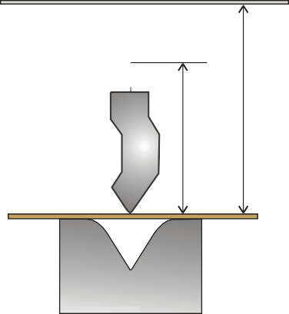
To die Stopping
Stopping
Upper die
Arrival time
Time to return
Lower Mode


2. click on the page A dialog box will pop up to prompt the user to log in. Please enter the correct password (8888) and click again to start setting the parameters:

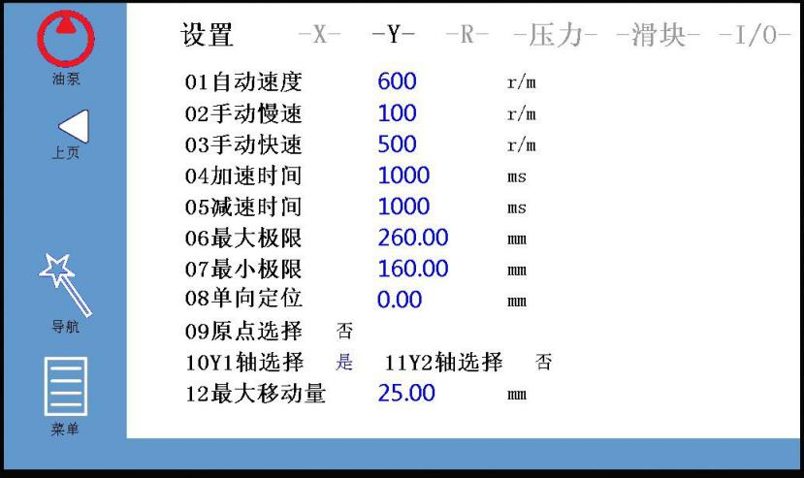

X/Y/R axis settings
On the parameter setting page, the operator can set the motion parameters of the X/Y axis (optional Y2/R axis) and the pressure and slider related parameters during bending.

The R axis can be enabled by clicking on "R axis is valid ", as shown below:
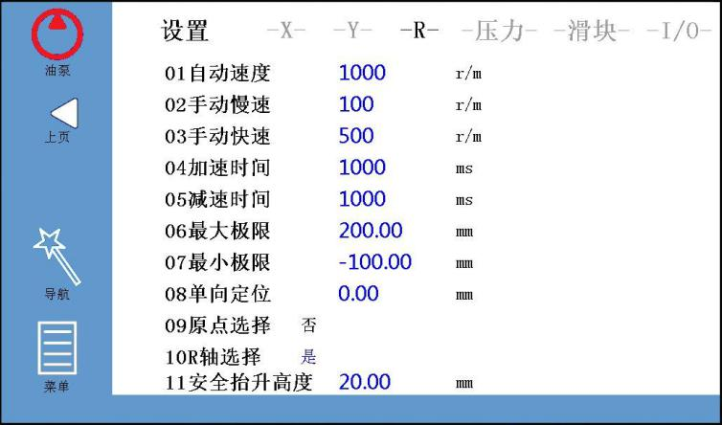

After that, the relevant information and setting icon of the R axis are displayed on the programming page. Click on the red box to set the parameters of each block, which is convenient to use different blocks according to the workpiece processed in operation.

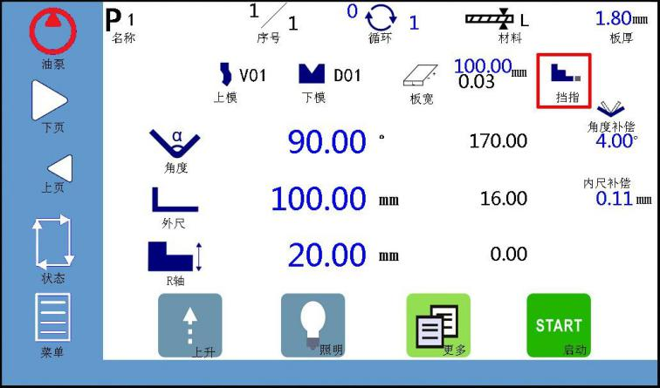
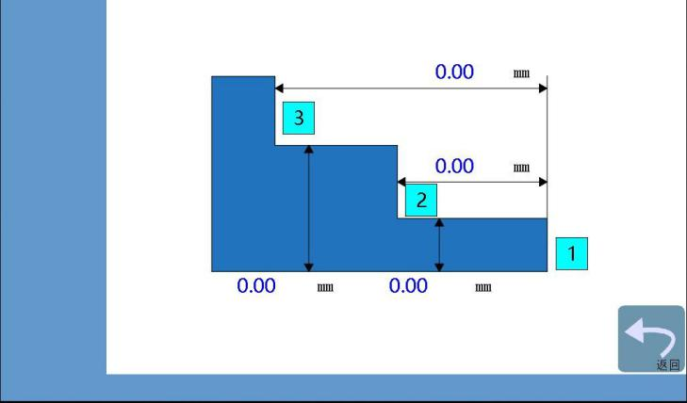
Pressure settings

The operator can record the bending pressure and deflection under different electrical signals under the "-pressure-" page. The system will calculate the linear relationship between bending pressure and voltage, deflection and voltage according to the internal algorithm, which is convenient to compensate according to the specific pressure value and deflection value input in practice. given the pressure and deflection simulation values set on the "machine status" page, see "chapter 1.3 machine status ".

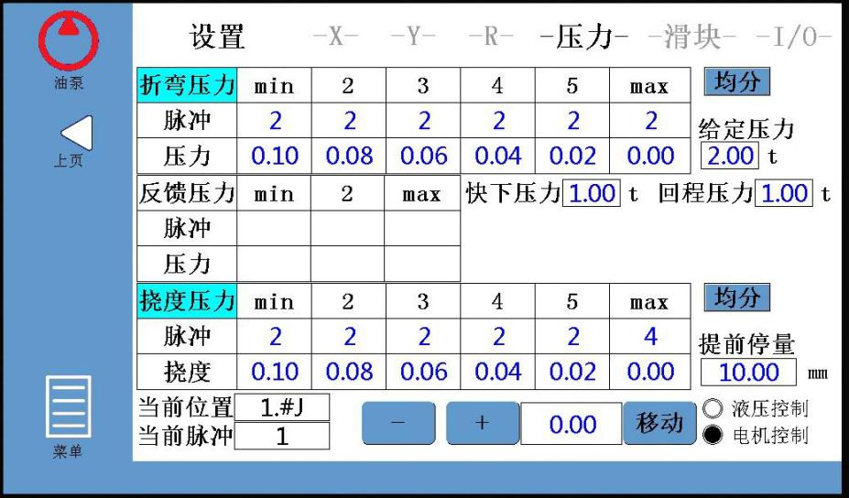
Slider setting
The operator can set the relevant parameters on the "-slider-" page and set the grating ruler according to the actual situation, as shown in the following figure:
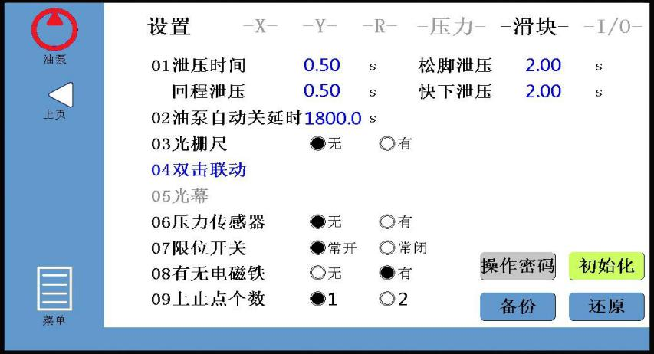

>< remarks

- Pressure relief time: pressure relief duration after the arrival of the start of the return journey.

- Oil pump automatic shutdown delay: when the machine is not operated, the oil pump automatically closes after that time. Default :1800 seconds, set range :300~3276.7 seconds.

Machine state

Operators can enter the machine status page in a variety of ways.

As shown below, in the programming main page, click on the icon, you can enter the machine status page.
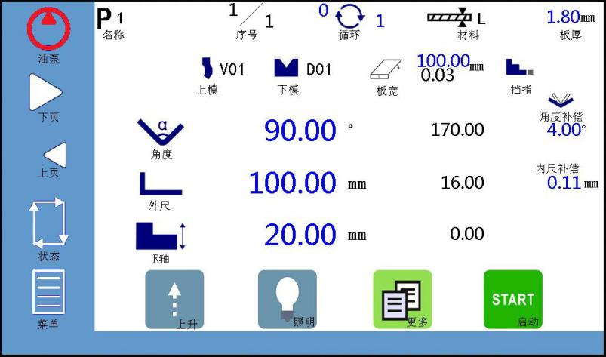
As shown below, in the manual movement page, click on the left red box icon, you can enter the machine status page.
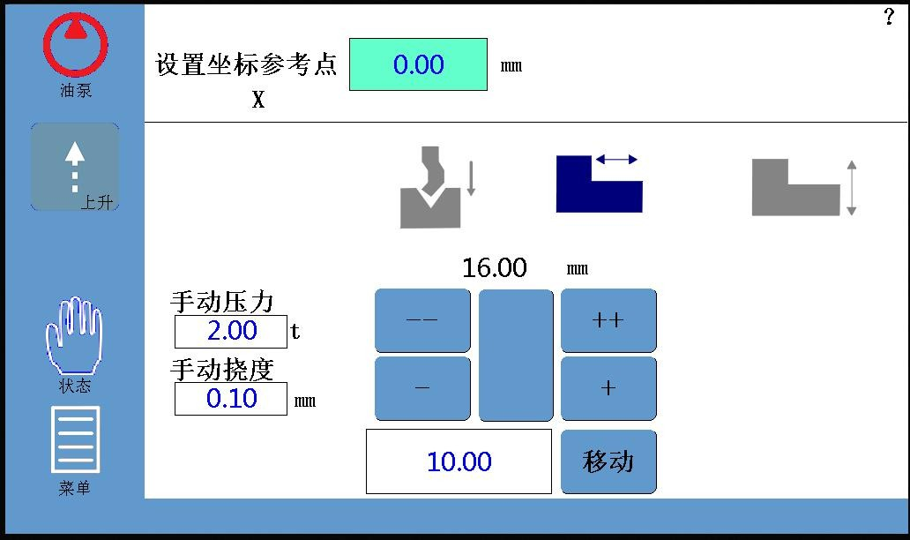
As shown below, on the parameter setting page, click on the icon in the left red box to enter the machine status page.

On the machine status page, the operator can observe the system input / output signal and analyze the possible problems more conveniently.
In the output window, click the output, and the lower window displays the functional control status of each output port, as shown below:

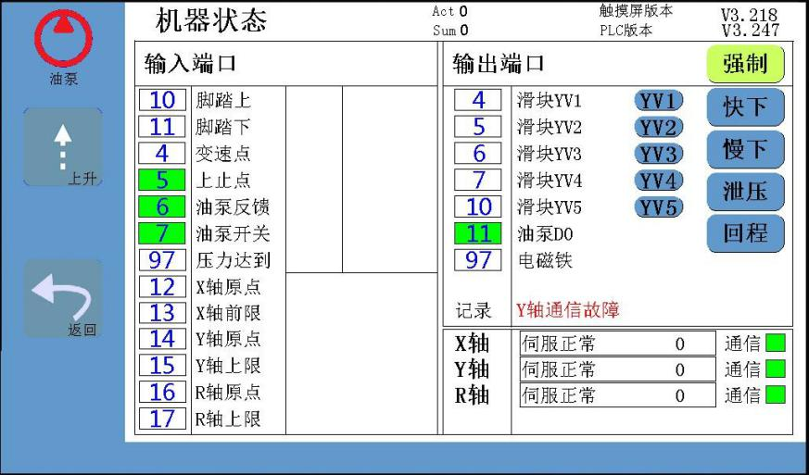

If the box corresponding to the input / output command shows green, the signal or function is normal. Pole: set the maximum height of the rise before setting the grating ruler

Manual movement

The operator can move the Y shaft (slider), the X shaft (rear retaining material) in manual mode, or choose the R shaft according to the situation (retaining finger).
1. click the menu icon on the main programming page, click "manual movement" in the pop-up menu, and enter the manual page (to set the X/Y/R axis reference point coordinates, you need to enter the password "8888"):

2. set the reference point for the X axis

Use the measuring tool to measure the length of a reference position (from the clamping point to the rear block) and write the measured value in the settings above the rear block icon.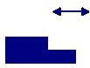
3. set the reference point for the Y axis

Step down and press down, then measure a reference position (from the bottom of the lower die to the top of the upper die) using a measuring tool

Length, and finally write the measured value in the settings above the slider icon.
4. set the reference point for the R axis

The R shaft is used to select the retaining finger, and the X and R shaft fit

motion can prevent collision die. The operator uses the measuring tool to measure the distance from the working plane of the lower die to the lower plane of the block, and writes the measured value in the upper setting.
5./++ in the above picture is manual slow / fast movement, click the "move" button on the corresponding page, the X/Y/R axis will be pressed
Set the speed to move the specified distance, click the button again to stop moving.

- On the reference point setting page of the selected axis, hold down, the motor of the axis moves slowly in the direction of increasing count;
- On the reference point setting page of the selected axis, hold down, the motor of the axis moves slowly in the direction of the subtraction count;
- On the reference point setting page of the selected axis, hold down, the motor of the axis moves rapidly in the direction of increasing count;
- At the reference point setting page of the selected axis, hold down, the motor of the axis moves rapidly in the direction of the subtraction count; while moving the axis, the current value of the X/Y/R axis coordinates changes with it until it moves to the appropriate position to stop.
< note >: the system has a given position limit function, if the given location exceeds the set minimum / maximum limit, whenever the system on time will prompt "given position limit" and invalid.

Mold management

CNC system automatically calculates the programming value of the X/Y/R axis according to the selected die, bending angle and bending length. Die parameters are the basis of system calculation, must ensure accuracy.

Top Editor

1. click on the upper mold icon on the programming page to enter the mold editing page:
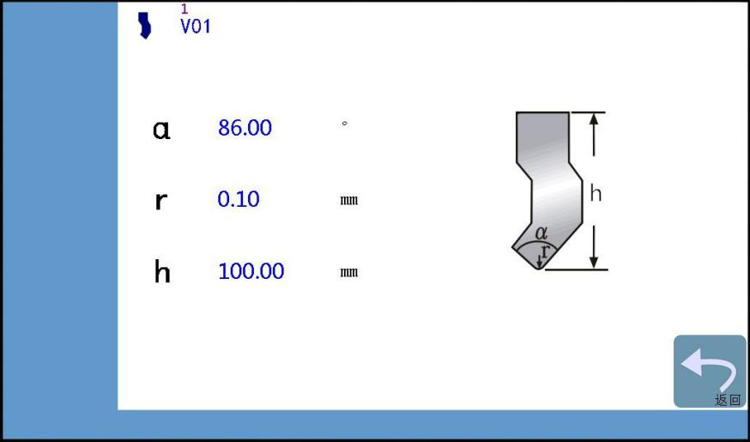
2. the upper die in the following figure as an example, enter the upper die data (α： upper die angle, r ： chamfer, h ： upper die height)

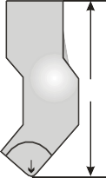
α 88. 00 °
h
α
r
r 0.20 mm
h mm 150.00

3. the data input is complete, click Next to the input field, according to their own requirements naming rules to name the mold, with the given name to save the current upper mold ,(up to 30 upper mold information can be saved)
After 4. completion of the above steps, the upper model data will be automatically saved for subsequent use.

5. click on the top icon then click or browse the saved mold information.

6. click on the icon and return to the programming page.

Lower Mode Editor

1. click the next icon on the edit page and go to the mold edit page, as shown below:
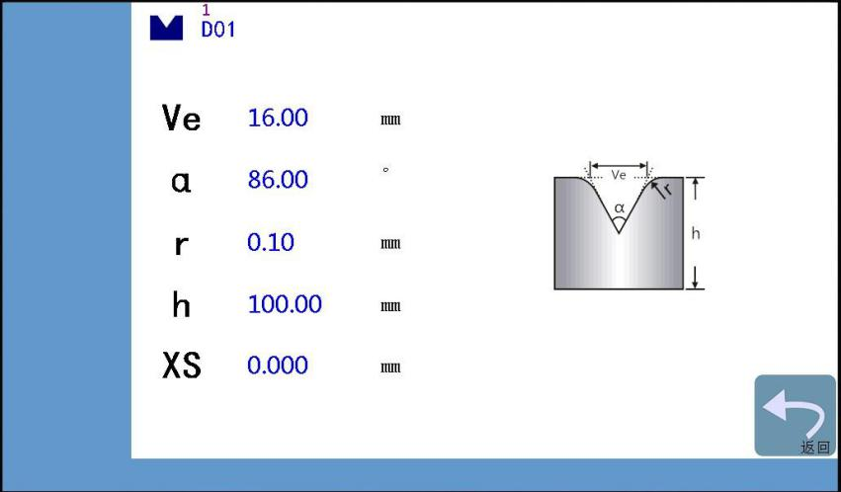
2. the lower die in the following figure as an example, enter the lower die data (Ve ： opening width ,α： opening angle, r ： chamfer, h ： lower die height)


Ve 12.00 (12.43)
Ve
α
r r
h
α 88. 00 °
r 0.20 mm
h mm 95.00

After 3. the input of the next model data, click Next to the input field, according to their own requirements naming rules to name the mold, with a name to save the current lower mold (up to 40 lower mold information can be saved)
After 4. completion of the above steps, the next model data will be automatically saved for subsequent use.

5. click the next icon then click or browse the saved mold.

6. click on the icon and return to the programming page.

Examples of applications

This chapter combines panel and machine tool operation, and introduces how to process a workpiece that needs multiple bending with a concrete example.A schematic diagram of the position and direction of the X/Y axis is as follows:


Example Description

This example is illustrated by programming the following products:
Step 1 Bending Step 2 Bending
mm 2
100 mm
90°
120°
60 mm 80 mm

>< remarks
    - If you encounter an emergency or need to return during the operation, you can click the button to return to the dead point.
    - If the back gear retreat distance is set, the back gear begins to retreat after the clamping time arrives.

1. select the lower mold opening Ve

Referring to the following table, if the thickness of the bending sheet is 2 mm, it is necessary to select the groove with a width of 6 times the thickness of the plate, that is, the Ve of the bending groove should be selected for 12 mm ..1
Criteria for selecting lower die openings
workpiece thickness T (mm) | 0.6~2.5 | 3~8 | 10~50
lower die opening width W (mm) | 6T | 8T | 10T

2. bending step

Step 1: bending angle 90.00°, bending length L 60.00 mm

Step 2: bending angle is 120.00°, bending length L is 80.00 mm

3. work mode selection

Three working modes are available: click, single, continuous.

These work modes support automatic step change, after the first step of bending will automatically enter the next step.

< remarks > please refer to section "1.2 parameter settings "for details of the relevant working mode.

Operation steps

1. power on

First, turn on the main power switch on the cabinet, and then start the oil pump (the machine does not work at this time).

< note > do not press the stop button, otherwise the machine can not operate, oil pump can not start.

2. Display Panel Basic Settings
- Click on the icon on the main page of the program and enter the plate thickness (2 mm).
- Click on the mold icon or edit the mold (up / down) on the pop-up page.The upper model is edited as follows:

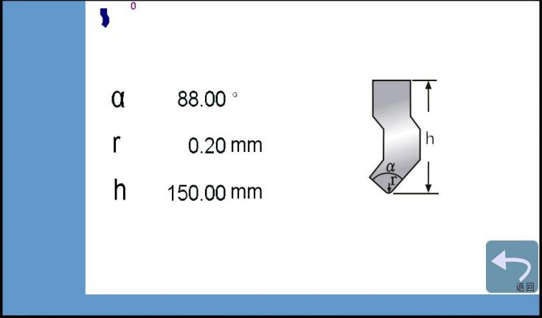
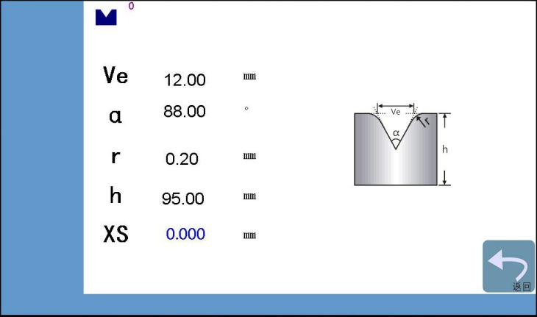
Edit the following:

- Click the icon on the main programming page to enter more bending data:

< remarks > please refer to section "1.2.2 more data setting page ".

3. calibrated by manual movement mode
The operator can move the Y shaft (slider), the X shaft (rear retaining material) and the R shaft (retaining finger) for position calibration in manual mode.
- Click on the menu icon on the programming page, select "manual move" in the pop-up menu, and go to the manual page.
- Click -/++ or button to move the selected Y axis (slider)/ X axis (rear block)/ R axis (finger). While moving each axis, the current value of the axis coordinates changes with it until it moves to the right position to stop moving.
- Setting the reference point for the X axis

Use the measuring tool to measure the length of a reference position (from the clamping point to the rear block) and write the measured value in the settings above the rear block icon.
A method of measuring the length from the clamping point to the back block: after the X axis moves at any distance, take a sheet metal between the upper and lower die, push the sheet metal to hold the back block, then step down, make the upper die move down to just press the sheet (a little strong but the sheet is not deformed), and finally step on the top to return the die to the dead point, and measure the vertical distance between the imprint mark and the small plate on the back block side, that is, the length from the clamping point to the back block.
- Setting the reference point for the Y axis
Use the measuring tool to measure the length of a reference position (from the bottom of the lower die to the top of the upper die), and then write the measured value in the setting above the rear block icon.
A method of measuring the distance from the bottom surface of the lower die to the top surface of the upper die: stepping on the foot to make the upper die return to the upper dead point, moving the Y axis arbitrarily for a distance, stepping down, making the upper die move down to the slider position (that is, no longer down). Finally, the vertical distance from the bottom of the lower die to the top of the upper die is measured.

Appendix:
Analysis and treatment of A common problems

Table B-1 FAQ Analysis and Handling
Problem description | Causes and Solutions
Oil pump not activated | - Whether the stop button is loosened.  - Oil pump feedback signal is normal.  - The oil pump icon on the touch screen needs to be pressed for 3 seconds.
Stop after pump starts | - Oil pump self-off delay set too short  - Contact coil loose  - Oil pump feedback signal loose stop
Servo communications | - CPU and back gear servo, servo and servo communication line is connected.
XY axis servo (manual) unable to move | - Servo communication is normal  - Servo alarm (if not clear alarm, need to re-power).  - Whether the motor line is connected correctly.
Y axis servo (manual) unable to move | - The upper die rises to the top (the upper dead point must have a signal)
After the parameters are set, press the "START" or step switch on the touch screen to have no uniform reaction | - Whether the stop button is loosened. Whether the oil pump is on.  - Servo is normal.  - Whether the die is raised to the top (if not alarm, need to re-power).
No action of hydraulic brake | - Stop button release  - Oil pump activated  - Whether the gate is configured (set the parameter page on the touch screen).
Slider movement abnormal | - Check that the pressure holding time "pressure relief time" and "return time" are set reasonably.  - Variable speed point and dead point information are normal.  - Pump start  - Stop switch release  - Enter the hole hand moving screen (if the XY axis is not debugged at this time)
The bending angle error of the first knife is very large (>5°) | - Whether the die is flat.  - Measure the height after pressing and the calculated height of the system is consistent, if inconsistent re-axis calibration.  - Check that the set die parameters, plate thickness is correct.  - The selection of wire rod (belt) accuracy is not enough.  - Whether the thickness of the workpiece plate is reasonable or not, select point 1 in the reference section 2.1 example description  - The workpiece uses very elastic steel, which needs angle compensation.
X axis automatic mode positioning is not in place | - Bending machine on both sides of the wire rod installation is not parallel, resulting in the motor to a certain position  Fixed; can be manually moved throughout the X axis to verify, if the case of immovable, it means that there is a problem.
Bending Angle Error | - Check that machine pressure is adequate
Calibrate the angle, change a sheet after bending angle is not right | - Different materials, different width of sheet metal bending parameters are different to set and compensate separately.
Next step bending angle error | - Whether the grinding tool number used in the next step has changed.
The angle compensation is not correct | - The system automatically limits the safety height of the lower die ([bending depth + compensation ]> minimum height).

